Dear Sirs:
Many thanks for your enquiry! Please kindly check the below best quotation we offer to you. And don't hesitate to contact us if you have any questions, hoping to work as your partner in near future, you are welcome to visit us!

PART 1 MAIN TECHNICAL INFORMATION
Diesel engine model | MAN 6L27/38
Number of cylinders | 6
Cylinder bore | 270mm
Piston stroke | 380mm
Rotate speed | 720rpm
Engine power | 1980kw
Generator set power | 1900kw
Generator type | HYUNDAI HFJ7710-10P
HZ | 60hz
Voltage | 690v
POWER FACTOR （lag ） | 0.9
Manufacturer | DOOSAN– MAN authorized manufacturer/ Korea
Year of made | 2020
Dimensions | 7557*3712*2570mm
Weight （dry weight） | 44500kg

PART 2 SUPPLY LIST OF OTHER DOCUMENTS
2.1 OPERATING INSTRUCTIONS
2.2 WORKING INSTRUCTIONS
2.3 FAT REPORT
PART 3 SUPPLY SCOPE
3.1 MAN 6L27//38 engine
3.2 HYUNDAI HFJ7710-10P generator
PART 4 PICTURES AND DEMENSIONS

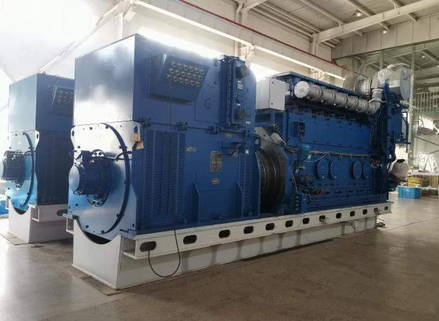
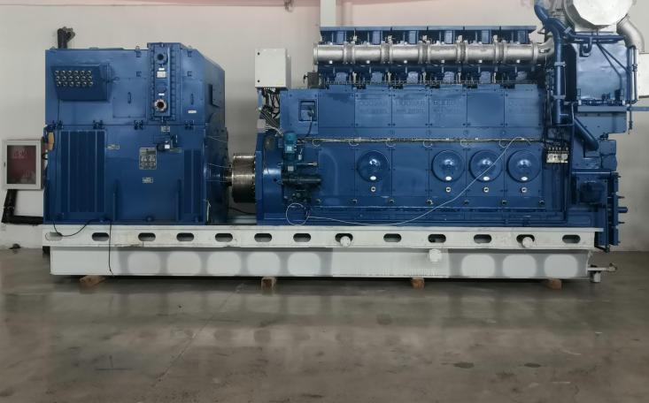

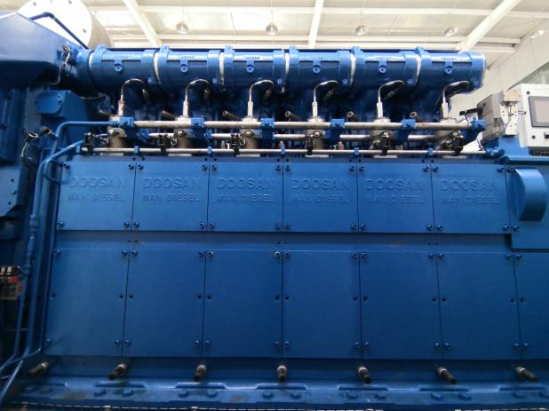

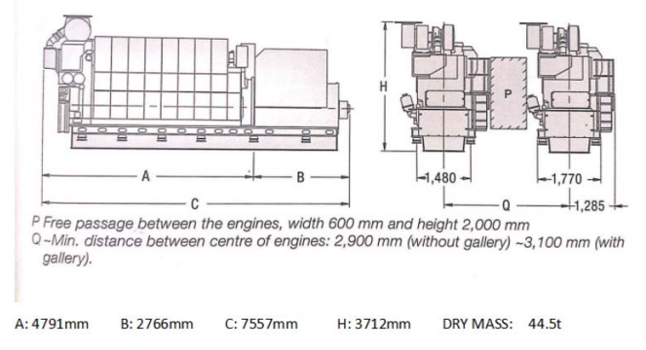

PART 6 QUOTATIONS
ITEM | NAME | MODEL | Q'TY | Per/SET  (USD) | TOTAL AMOUNT  (USD)
1 | GENERATOR SET | DOOSAN-MAN 6L27/38 1900 Kw x 720 RPM x 690v x 60 Hz | 4

REMARKS AND INSTRUCTIONS:
1. PRICE TERMS : EXW WORKS QINHUANGDAO CHINA IN USD, OTHER CHARGES AT COST. EXCHANGE RATE IS SET 1USD≥7.07RMB.
2. VALIDITY : 60 DAYS, SUBJECT TO PRIOR SALE.
3. CONDITION : MADE IN KOREA, JUST DID FOR TEST RUNNING, NOT PUT INTO COMMERCIAL OPERATION.
4. PAYMENT TERMS : BY T/T 30% IN ADVANCE, THE BALANCE PAID BEFORE SHIPMENT.
5.DELIVERY TIME : IN STOCK, IMMEDIATELY DELIVERY AVALIABLE.

